Air Pressure: Balloon and Cups.
Collaborative experimental task: Investigative activity
VELS level 3: Grades 3&4

Introduction:
The experiment Air Pressure: Balloon and Cup involves difference in air pressure. It is hypothisised that the higher pressure in the balloon vs the lower pressure in the cup will result in the cup sticking to the outside of the balloon. Students will learn about forces in terms of push and pull.

Knowledge and understanding:
While working toward VELS level 3 student identify the actions of forces in everyday situations. They use words sush as push and pull to describe how things can be moved or stopped. They identify forms of energy and energy transformations in the everyday world. They use appropriate scientific terminology to describe and explain their observations and investigations.

Science at work:
“At Level 3, students plan, design, conduct and report collaboratively on experiments related to their questions about living and non-living things and events. They select and use simple measuring equipment, use a range of appropriate methods to record observations, and comment on trends. They describe the concept of a fair test and identify the variables associated with an experiment. They develop fair tests to make comparisons and explain how they have controlled experimental variables.”
“Students describe safety requirements and procedures associated with experiments. They explain how scientific knowledge is used, or could be used, to solve a social issue or problem. They describe aspects of the work of scientists and how this has contributed to science knowledge.”

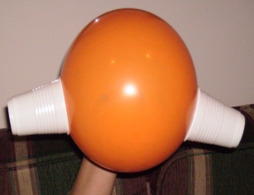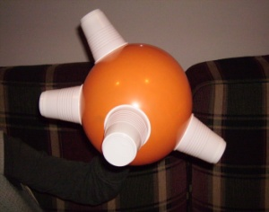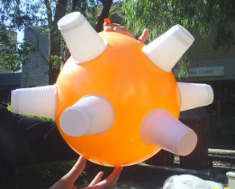

Air Pressure: Balloon and Cups.

Purpose of the experiment:
To test how many plastic cups will stick to the inflated balloon.

Hypothesis:
We hypothesise that 8 plastic cups will stick the the balloon once it is fully inflated.

Materials:
1.Balloon
2.Plastic disposable cups
And…
3.Lots of PUFF!

Method: (In pairs)
Blow up the balloon just a little bit.
Get your partner to place 2 cups against the balloon applying pressure.(push)
Slowly blow up the balloon further still aplying pressure to the cups.
Hold cups until they stick carefully removing pressure slowly to check they have stuck.
Once the 2 cups have stuck repeat method with 2 more cups.
Continue this method until the balloon is fully inflated or no more cups will stick to the balloon.
Results:
Attempts | Number of cups 1st puff | Number of cups 2nd puff | Number of cups 3rd puff | Number of cups 4th puff | Number of cups 5th puff | Total number of cups on inflated balloon
1 | 0 | 2 | 0 | 0 | 0 | 2
2 | 2 | 0 | 2 | 0 | 0 | 4
3 | 2 | 2 | 2 | -5 | 0 | 1
4 | 2 | 2 | 2 | 0 | Balloon burst | 0
5 | 2 | 2 | 2 | 0 | 0 | 6

Discussion:
We found that the cups stuck to the balloon. It took five puffs to fully inflate the balloon.
Attempt one: only two cups stuck to the balloon. We found that increased pressure needed to be applied to the cups and that the balloon needed to be blown up more slowly to give greater chance for additional cups to be stuck.
Attempt two: we managed to get four cups to stick the the balloon. The change in strategy improved the result. We realised that we still needed to further decrease the speed that the ballloon was inflated.
Attempt three: we were able to get six cups to stick to the balloon after three puffs. We attempted to get eight cups to stick however, failed in our attempt and all the cups fell off the balloon apart from one.
Attempt four: we were able to stick six cups onto the balloon but the balloon burst after five puffs and we were left with no cups.
Attempt five: we were able to get six cups to stick to the balloon after three puffs. We attempted to apply two additional cups but failed in our attempt and were left with six cups in total both times.

Limitations :
We found that because the balloon is limited in the amount of air it can contain there was little opportunity to be able to stick a greater number than six cups to the balloon. On one failed attempt the ballon burst leaving us with zero cups. It is impossible to control and measure the amount of air being blown into each balloon therefor there is no controlable variable in this experiment. Another limitation is that if pressure is released too soon the seal is broken and therefore the cup looses its suction and the pressure is lost and the cup will not stick to the balloon.
This is a very safe experiment. One thing to consider is not to blow the balloon up too much as it may burst.

Conclusion:
We found that the cups stick to the balloon because the air in the balloon is at a higher pressure than the air in the cup. The inflating balloon creates a suction as it increases in size, so less of the balloon is actually inside the cup. This lowers the air pressure, the suction is actually the pressure of the air outside the cup “pushing” the cup into the balloon and causing it to stick.
The results show that our hypothesis was not met and that six is the total number of cups able to be stuck onto the balloon. We used normal 23cm round balloons.
Further investigation could involve testing if using the same method applied in this experiment a heavier cup such as a mug or glass will stick to the balloon.
How we delegated the activity:
We colaborated all data and performed the experiment together. Each section of the report was completed together. Equal share of workload was achieved.

Reference:
Ng, Wan. Primary science handbook. 2009
http://vels.vcaa.vic.edu.au/assessment/ppoint/science/index.html

